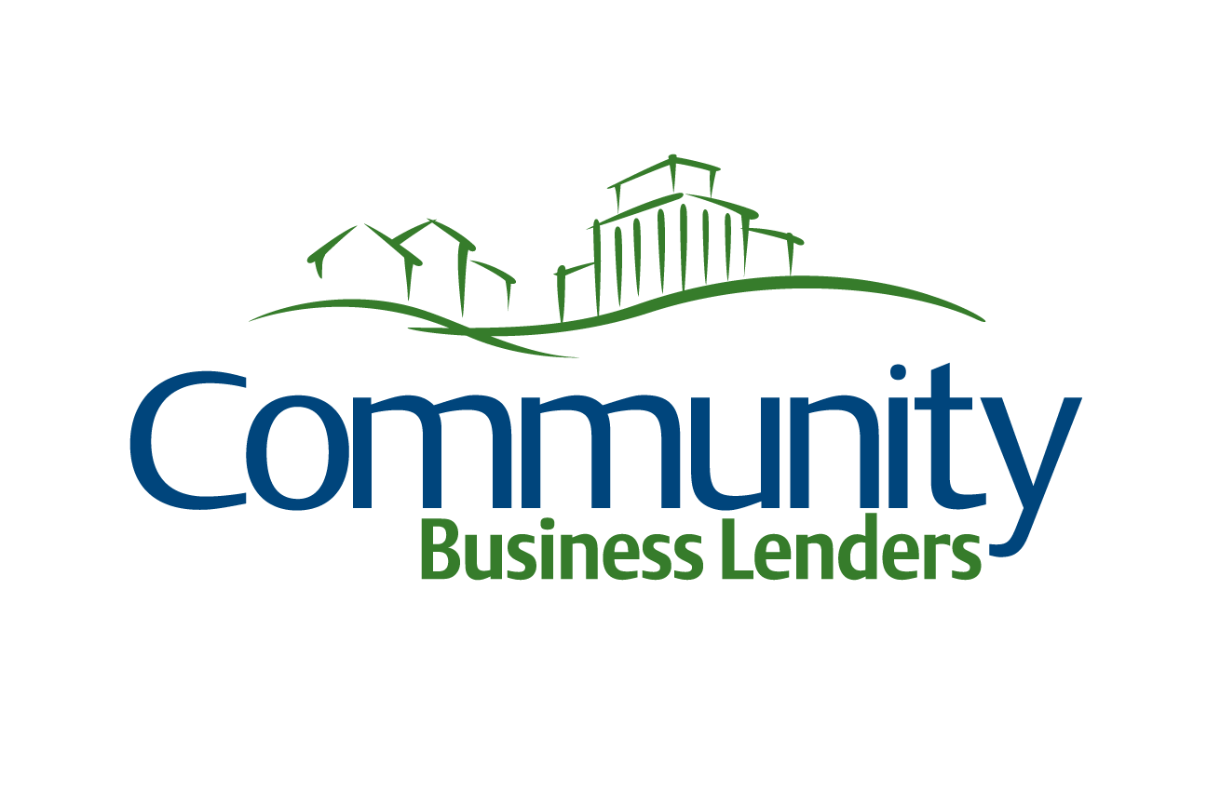

**Business Prospect Information Form**

|  |  |  |  |  |  |  |  |
| --- | --- | --- | --- | --- | --- | --- | --- |
| Date: | Credit Union: | | | | CU Contact: | | |
| Business Name: | | | | Business Contact: | | | |
| Address: | | City: | | | | | Zip: |
| Phone: | Cell: | | Fax: | | | Email: | |

1. Nature of business? (please include primary operations, ownership structure and any other pertinent information)
2. What do you plan to use the money for? (please describe)
3. How much money are you requesting? What loan terms are you requesting?
4. Collateral?
5. How will the loan be repaid? (example: rental income, business operations, etc.)
6. Current business loans? (if yes, please attach complete debt schedule)
7. Notes

**Items needed to review loan request:**

* 3 years business/personal tax returns
* Current business financial statements
* Governing documents
* Personal financial statement of all guarantors (signed and dated)
* Business plan (if new business)